14.50: a) Equation (14.4), with the radius instead of height 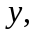 becomes 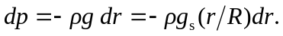 This form shows that the pressure decreases with increasing radius. Integrating, with 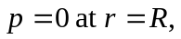

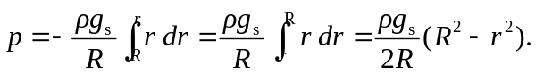

b) Using the above expression with 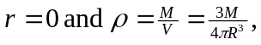

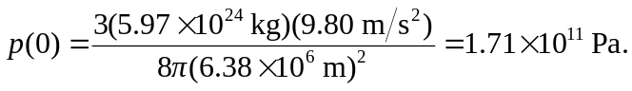

c) While the same order of magnitude, this is not in very good agreement with the estimated value. In more realistic density models (see Problem 14.49 or Problem 9.99), the concentration of mass at lower radii leads to a higher pressure.

